2014 South Sound STEM Robotics Invitational (rev. 4)
Monday, June 2
Jefferson Middle School, Olympia
9:30 a.m. – 1:30 p.m.
Team Guidelines
- Teams may compete in any or all events.
- Teams may have up to two entries in each event; one for the Red Bracket and one for the Blue Bracket
- High school and middle school teams will compete in separate divisions, running concurrently on different events.
- Unique robots (provided they meet the guidelines below) may be used for each event.
- Teams must confirm their intended number of entries in each event by Wednesday, May 28 so randomized brackets can be created in advance of the competition.
Event Procedures
- The three events (described below) will be run consecutively for each division (high school and middle school) to allow all participants to see all events and facilitate individuals competing in more than one event.
- Teams are responsible for tracking their progress through the red and blue brackets and having themselves in queue for their next match. There will be no runners or announcements for queuing. The brackets will be projected on screens and teams are encouraged to bring wifi-enabled devices to track the red and blue brackets in real-time online.
- During the competition, only students may modify the robots and make changes to programs.
- There will be a no-fly zone around each competition arena. Only one operator from each competing team will be allowed inside this zone, and then only for as long as necessary to facilitate the match.
- Teams need to allow time to test/adjust their robots under game-day conditions prior to each event.
- Each match of each event will begin with a one minute “call to start” warning. Teams unprepared to start on time will forfeit that run.
Robot Guidelines
Components: All robots will be constructed only from a single 9797 NXT kit (items as listed on the 9797 placards) or a single 45544 EV3 kit (items as listed on the 45544 inventory pdf) and the following additional allowed items:
(49.6 x 28 mm) or
(43.3 x 22 mm)
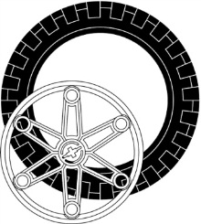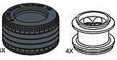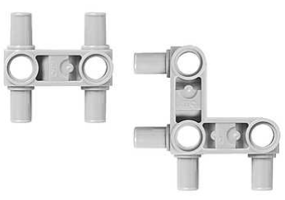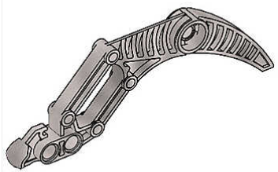
Large or Lawnmower Wheels (up to 2 each) Snap Beams (up to a total 10 each) Claw (up to 4)
Exceptions: EV3 Sumo-Bots may not use any of the black curved panels (parts #: 4543490, 4541326, 4566251, 4566249) or track pieces (part #6014648).
Size: All robots will fit inside a cube 12 inches on a side.
Exceptions: Dragsters may exceed 12 inches in one dimension.
Sumo-Bots may have appendages that extend out after competition begins.
Liner Racers’ wired-remote controls may extend beyond 12 inches from the robot.
Power: All robots will be powered by a LEGO NXT or EV3 rechargeable battery pack.
Software: All robots will be programmed by NXT-G, EV3-G, RobotC or NXC.
Design Modifications: Either hardware or software may be modified on the day of competition, provided the robot is ready to compete at its designated time.
Remote Control: Dragsters and Sumo-Bots are to run autonomously (with no remote control), not responding to any student input after the “Run” button is pressed. Line Racers may use only wired-remote controls. In no case is wireless robot control allowed.
The Events
Light Activated Dragsters
This will be a double-elimination competition.
This event will take place on ~4’x8’ whiteboards with center and outer lane stripes marked in black electrical tape.
Each lane will be approximately 23 inches wide and 20 feet long, with the finish line marked in black electrical tape.
The light/color sensor must be mounted at a fixed location at the rear of the dragster, with at least ¼ inch clearance above the ground and at least 1 inch behind the point at which the rear tires are ¼ inch above the ground.
Each dragster will be positioned at the starting line with its light/color sensor at least 4 inches from the outer lane stripe and directly over the light colored starting line tape (located ~18 inches from one end of the course).
Once the black starting “flag” (a 3/16 inch black foam board placed over the starting line, immediately behind the dragsters) is in place, teams will start their program and step away from the dragster.
The race will begin when the official abruptly removes the black starting “flag” horizontally away from the rear of the dragsters.
The race is over when the first dragster comes to a stop as a result of crossing the finish line. A dragster is considered to be stopped when it loses all of its forward momentum.
Note: This means various designs will extend different lengths beyond the starting line, however, each dragster’s light/color sensor (and hence the dragster itself) will travel the same distance to the finish line.
Only one false-start per match per entrant will be allowed. Failure to start moving after the “flag” is removed does not constitute a false start. It is recommended that teams check their sensor threshold under game-day conditions.
Any dragster that veers out of its lane will be disqualified in that race. If both dragsters exit their lanes before the finish line, the dragster which traveled further down the course before exiting will be declared the winner of that race.
A dragster may exceed 12” in one dimension.
Sumo-bots
This will be a double-elimination competition.
This event will take place on a ~4’x4’ whiteboard with a black border. The arena will be a white square 36” on a side. The arena will be slightly elevated to facilitate timely conclusion of matches.
Sumo-bot wrestling will begin with opponents in opposite corners and will continue until either one opponent is completely out of the arena, or one Sumo-bot is disabled.
The match will begin with a countdown, followed by the student pressing the “Run” button on the brick or a touch sensor connected to serve as a remote “Run” button. After pressing “Run”, the student must step out of the “no-fly” zone (at least 3 feet from the arena).
If, after one minute, there is no clear winner, the competition will be halted. After a second, abbreviated “call to start” (30 seconds), an additional one minute re-match will begin. For the rematch, Sumo-bots will be placed back-to-back in the center of the arena and must move forward or turn (may not move backwards) immediately after the start of the match. If there is no clear winner after the re-match, judges will declare a winner based on which Sumo-bot is least disabled, or has most nearly pushed its opponent from the arena during the matches.
The winning robot must either push its opponent completely out of the arena (not counting appendages extending beyond 12”), or disable its opponent (render opponent unable to maneuver, while victor Sumo-bot still can). If a robot is not pushed off the mat, but is flipped, the flipped Sumo-bot is considered disabled and loses the match.
Line Racers
This will be a double-elimination competition.
This event will take place on a ~4’x4’ whiteboard with rounded corners placed upon a waist-high table.
The course will be marked out in 5/8 inch black electrical tape. The tape lines will be:
- At least 5 inches from the edge of the whiteboard on all sides
- Laid out in straight lines or curves (no sharp angles)
- Laid out with curves having a minimum inner-diameter of no less than 4.5 inches
Racers will start opposite each other at randomly assigned starting points.
The race will be two laps, running counter-clockwise.
One driver will escort the Line Racer as it travels around the table. While escorting the Line Racer, drivers must avoid contact with each other.
The first Line Racer to cross its original starting position a second time wins (two laps of the course). If one Line Racer catches up with its opponent, it will be declared the winner.
If a Line Racer “loses” the line, the student may pick up the robot and immediately restart it at the point where it last successfully followed the line.
Line Racers must follow the line at all times, turning toward the nearest line when off it, and turning off the line when on top of it (no straight runs or fixed turns). A line following algorithm (one or more) must be used at all times during the race, except when briefly switching between algorithms (if more than one is used). All programs must be available for inspection to verify compliance with the above.
The wired-remote control may consist of one motor, structural components, and up to two sensors.
At no time can the Line Racer be moved by pulling on the remote control wires.

