Color Candy Sorter Instructor’s Guide
by Ian Chow-Miller

Materials:
LEGO EV3 Robotics Kit – the brain, battery, motor, and color sensors are essential. Beyond that each group will build their own “factories” so the more LEGO and specifically LEGO technic pieces you have available, the better.
A lot of groups like the tracks for a conveyor belt, so if you have those (the EV3 resource kit has extras) handy that’s great.
Internet access.
EV3 software on desktop/laptop/tablet – if you don’t get too fancy with your program you can use the iPad app, even though it has limited programming compared to the desktop software.
Candy – I use large gumballs that I get in a tube for $10 at World Market. You can use any type of candy that is readily available, and has at least four or five distinct colors.

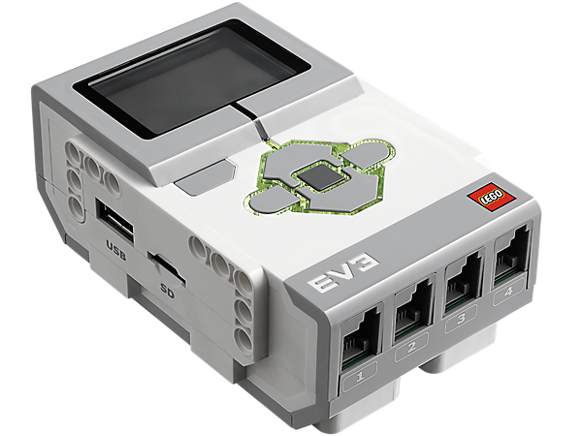 | 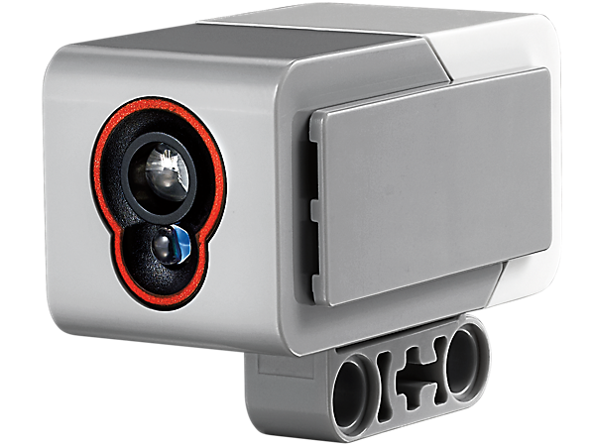 | 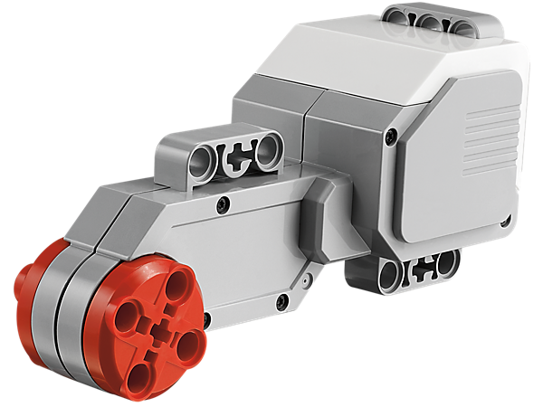
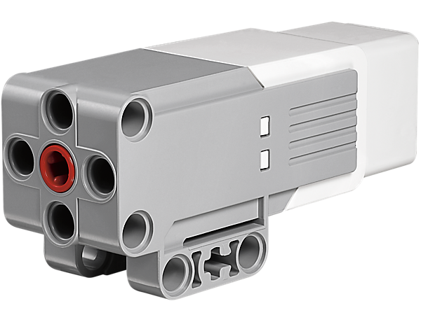 | 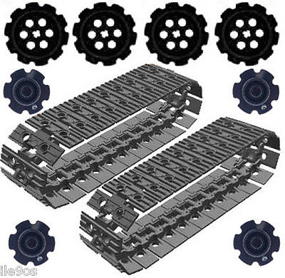

Day 1

I will often pair two teams up for this project, making larger groups of four (all my original teams are in pairs). The reason for this is to double the number of available pieces for building, especially the availability of four large motors (or a combination of mixing medium and large motors).

Start by showing the students a video of a successful candy sorter like this one here. This can start sparking the students’ interest in the process. After watching the video you can discuss how the candy sorters work. Ask them the following questions:

- How does the robot know that there are different colors? (color sensor)
- What are the various parts of the factory? (they may say things like ramp, gate, sorter, etc.)
- Write down the pseudo-code for a program that can sort things into different colors. (If you haven’t done pseudo-code with your students, then you can just as easily ask them to diagram or discuss the process they think a program would need to go through. Often they will write out quite accurately the steps a robot would need to take without realizing how close they are to the actual code.)

At this point I hand out a zip-loc bag of gumballs to each group. I include two of each color (red, blue, yellow, green, white) and tell them it will cost them a deduction on their grade to replace any missing ones. This usually stops the occasional hungry student from taking a gumball.

You can take the students through the rest of this lesson by following along with the slide show provided in Primary Instructional Materials. There are questions posed in the slideshow that the students can answer on their devices or on a piece of paper if you are presenting the slide show to the class as a whole.

(I’m assuming you have not used the color sensor with your students at this point, but if you have, please adjust accordingly.) This next part is easier if you have iPads with the EV3 app, but can be done with desk/lap tops. Have students plug the color sensor into their EV3.

Have students choose port view on the software, app, or brick (it’s harder to see on the brick) and navigate to the correct port the color sensor is plugged into. The first thing they will notice is there are three modes the color sensor can be used to measure: ambient light, reflective light, and color.

After teaching each of the three modes, have the students play with the sensor in each mode and see what sort of readings they get around the classroom.

To teach ambient light, I have my students look up at the overhead lights, close their eyes, then pass their hand back and forth in front of their closed eyes. That change in lightness and darkness is ambient light. Ambient light can be defined as the total amount of available light in a given area, like a room.

For reflective light I have students look at the color sensor and count the number of bulbs they see. There are two. One of them shoots out a beam of light and the other measures how much of that beam is reflected back. Ask your students if they think dark or light colors will reflect back more light. If they have trouble with the answer ask them what type of shirt their mother tells them to wear on a hot summer day. Usually it’s a lighter one because that absorbs less of the sun’s heat. And it’s the same with the color sensor in reflective mode; light colors reflect more and darker colors reflect less. The EV3 color sensor reports a range of 1-100% of light being reflected back.

Finally use the color sensor in color mode. The EV3 color sensor reads certain colors (black, white, red, yellow, green, blue, and no color). It reads LEGO colors the best, but can still read colors in other items. Have the students try to get different readings from the gumballs you handed out to them. The most important thing here is to demonstrate that how far away from the gumball you hold the sensor makes a huge difference in obtaining an accurate reading.

Day 2

Begin with reviewing the work from day one, specifically leading towards how the color sensor read colors. Make sure the students recognize that the color sensor needs to be close to the item and held still. This will be very important as the students in my experience have a tendency to place the color sensor too far away from the gumballs.

Have students take out the pseudo-code they wrote the previous day. Review it with them and then tease out the idea of making decisions. If one condition is met, a specific action is chosen, if a different condition is met, a different action is taken. As you go through this with them, use the Power Point to show them how to program a switch. It’s important for them to understand that you can’t show them the exact program they will need because everybody will build their candy sorter differently, but the general principles of how to program with a switch are the same.

If students struggle with the concept of switches have them look at the supplemental power point from http://ev3lessons.com/lessons.html#en-us. It walks them through two exercises using switches that only require a touch sensor and use of the display blocks.

Day 3

After students have seen different examples, practiced with the color sensor, and learned about programming with a switch, they are ready to start building their machine. Ideally each team will approach the problem differently. As the teacher you can only offer suggestions and advice, but the students must be allowed to make their own mistakes. It should take about 4-6 more class periods at this point for them to complete and share their projects.

