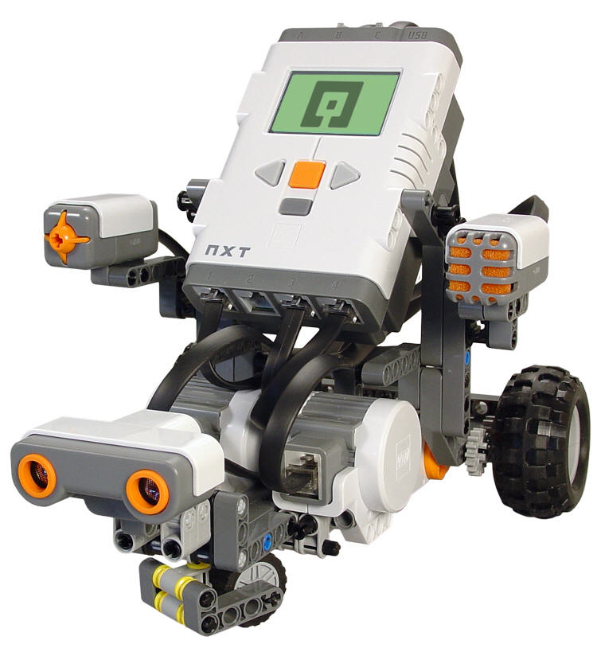

*May 2012*

“Move until Dark/Light

YOUR TEAM HAS SUCCESSFULLY ENGINEERED AND PROGRAMMED YOUR ROBOT TO

Samantha

Congratulations

**Jessicarae Nuñez**

**Rich Bakala**

YOUR TEAM HAS SUCCESSFULLY ENGINEERED AND PROGRAMMED YOUR ROBOT TO

“Move until Dark/Light

*May 2012*

**Jessicarae Nuñez**

**Rich Bakala**

Congratulations

Jake and Riley

Garrett, Xavier and Zach

Congratulations

**Rich Bakala**

**Jessicarae Nuñez**

*May 2012*

“Move until Dark/Light

YOUR TEAM HAS SUCCESSFULLY ENGINEERED AND PROGRAMMED YOUR ROBOT TO

YOUR TEAM HAS SUCCESSFULLY ENGINEERED AND PROGRAMMED YOUR ROBOT TO

“Move until Dark/Light

*May 2012*

**Jessicarae Nuñez**

**Rich Bakala**

Congratulations

Walid

Tristan and Jose

Congratulations

**Rich Bakala**

**Jessicarae Nuñez**

*May 2012*

“Move until Dark/Light

YOUR TEAM HAS SUCCESSFULLY ENGINEERED AND PROGRAMMED YOUR ROBOT TO

YOUR TEAM HAS SUCCESSFULLY ENGINEERED AND PROGRAMMED YOUR ROBOT TO

“Move until Dark/Light

*May 2012*

**Jessicarae Nuñez**

**Rich Bakala**

Congratulations

Henry and Mark

YOUR TEAM HAS SUCCESSFULLY ENGINEERED AND PROGRAMMED YOUR ROBOT TO

“Move until Dark/Light

*May 2012*

**Jessicarae Nuñez**

**Rich Bakala**

Congratulations

Nathan and Josh

YOUR TEAM HAS SUCCESSFULLY ENGINEERED AND PROGRAMMED YOUR ROBOT TO

“Move until Dark/Light

*May 2012*

**Jessicarae Nuñez**

**Rich Bakala**

Congratulations

Zachariah and Saber

YOUR TEAM HAS SUCCESSFULLY ENGINEERED AND PROGRAMMED YOUR ROBOT TO

“Move until Dark/Light

*May 2012*

**Jessicarae Nuñez**

**Rich Bakala**

Congratulations

Emma and Brittney