Introduction to Programming
Lego Mindstorm EV3
Behaviors: Sensors – Move Until Near 1-5 & C (found online in Robotics Academy EV3)
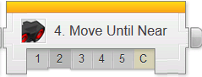
Check the boxes ✓ as you finish each task.
❐ Watch: Ultrasonic 1 : Introduction to Hexarotor
1. Why might the Rangefinders (Laser or Ultrasonic) be preferred over Touch Sensors for detecting walls and obstacles?
- Hitting wall could damage the wall
- Hitting a wall could damage the robot
- It is quicker to detect obstacles at a distance
- All of the above

❐ Do: Ultrasonic 2: Robot Config
❐ Watch: Ultrasonic 3: Wait for Near
1. What does the Wait Block wait for before playing the "Hello" sound?
- The Ultrasonic Sensor to detect an object less than 50 cm away
- The Ultrasonic Sensor to detect an object more than 50 cm away
- The robot to travel less than 50 cm
- The Ultrasonic Sensor's reading to change by up to 50 cm

2. How do you select the sound file the robot plays?
- By clicking in the upper-right "File Name" blank on the block
- By speaking into the speakers of the EV3
- By adding a File Block

❐ Do: Mini Challenge 1: Threshold Value
The Wait - Ultrasonic Sensor Block uses a "_____________" to define what it is waiting for.
Rather than look for a specific value (like 1cm or 200cm), it sets a "________________" value that divides all the possible Ultrasonic Sensor values into two categories:
If the distance value is above the Threshold, it is considered "______"
If the distance value is below the Threshold, it is considered "______"
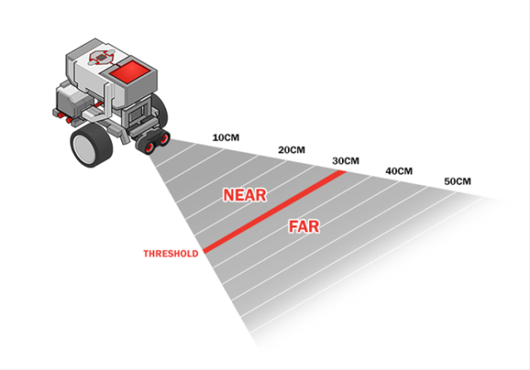
This way, the Wait Block does not have to worry about the difference between an object at 29cm and an object at 30cm; it only has to worry about whether the value is above or below the Threshold.
❐ Show Teacher: Mini Challenge 1: Threshold Value 10cm & 100cm

❐ Do: Try It! 1: Missing Object Alarm (Wait for Far)
Change the Wait Block's "Compare Type" setting to Greater Than (2). What does the Wait Block do if you set it to wait for a value Greater Than the Threshold instead of Less Than?
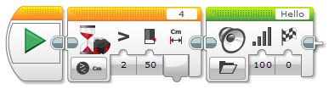

Place an object in front of the robot, and download and run the program. Now, try moving the object and see what happens.
What happens?

❐ Watch: Did You Know?: How the Ultrasonic Sensor Works
❐ Show Teacher: Try It! 2: Sound Sentences
- How would you get the EV3 to say one sound after another?

❐ Do: Try It! 3: Sensor Change Mode
What happens after changing the Mode of the Wait Block to Ultrasonic Sensor-Change – Distance Centimeters with direction setting to “Any” (2) and Amount setting to “5”?

❐ Watch: Ultrasonic 4: Froward Until Near
If the robot is facing a wall, it will move until...
- The Ultrasonic Sensor has traveled 50 cm
- The Ultrasonic Sensor is 50 cm from the wall
- The robot moves 50 cm total
- The robot detects an obstacle beyond 50 cm away

❐ Show Teacher: Mini Challenge 1: Backward Until Far

❐ Ultrasonic 5 : Ultrasonic Sensor Review

Write a detailed explanation for the following program blocks:
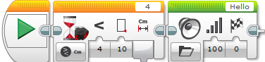

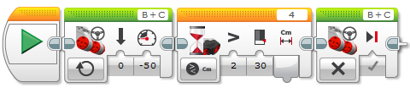

❐ Do: Ultrasonic 6 : Maze Challenge
❐ Show Teacher: Ultrasonic 6 : Maze Challenge

Upon completion of the Behaviors-Move Until Near module 1-5 & C, you should have the following programs in a project titled “LastName_ULTRASONIC” (you should also update your program documentation file with a new slide titled Ultrasonic containing the programs and description/picture for each maneuver):
❐ Threshold Value 10cm & 100cm
❐ Sound Sentences
❐ Backward Until Far
❐ Maze Challenge

