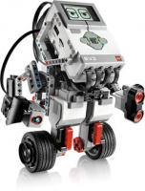

J. J. Co.

Josh and Jose.

The Engineering team

**Student’s naMe**

# Rich Bakala

# March 2014

Successfully completed Tasks and challenges related to

“robot Turning”



**#1**

This certifies

The Engineering team



**#1**

This certifies