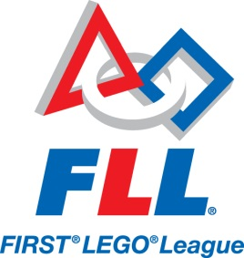
Jefferson Varsity FIRST® LEGO® League Team

In September 2016, the Varsity Robotics Team will be launched to create an opportunity for students to compete in the FIRST® LEGO® League competition (http://firstlegoleague.org)
We are looking for motivated and team-oriented students interested in taking their Robotics skills to the next level. FLL teams compete on three fronts:
- Robot Game – design, build and program a robot to autonomously complete a series of missions around this year’s theme: “Animal Allies” (http://www.firstlegoleague.org/challenge)
- Project – identify a problem, research/develop an innovative solution, and create an entertaining presentation of your work
- Core Values – demonstrate teamwork and the other FLL Core Values (http://www.firstlegoleague.org/mission/corevalues)

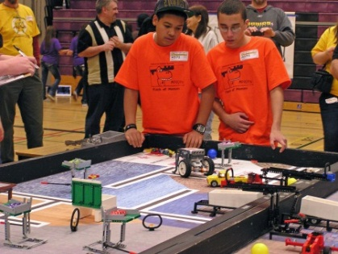
The club will initially meet after school Wednesdays and Thursdays from 2:35 to 4:00 p.m. Additional meetings may be added as the season progresses.
The club will run at as long as a team is in contention; December for the Regional Qualifier, or January for the State Semi-finals and State Championships.
Here are some things to keep in mind if you are considering applying to be on the Varsity Robotics Team for your middle school:
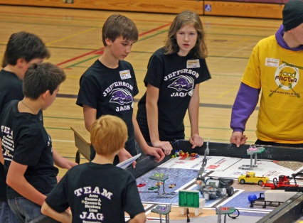
- FLL’s Core Values (http://firstlegoleague.org/mission/corevalues) stress teamwork, so you must be committed to work with others to find compromise and be able to give and receive positive/constructive feedback as your team develops their solutions – you must be a team player
- Your ability to work hard as part of team to complete whatever task needs to be addressed is essential – you must be flexible
- Regular attendance at the club is vital – you must be reliable
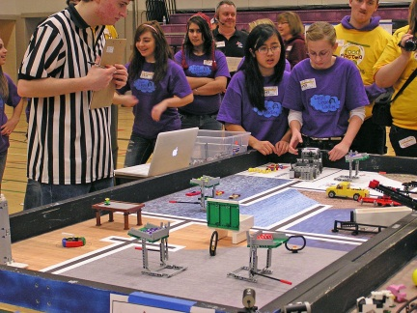
- Some work outside of club hours will be required (research, preparation, competitions) – you must be committed
- This is a varsity team, so you will be expected to bring some skills to the team in at least one of the competition areas– you must be experienced
- Students do all the work at FLL, so you will be expected to multi-task and take on responsibilities outside of your comfort zone – you must be willing to grow
- You will be representing your school at the club and competitions, so your behavior must be exemplary at all times – you must be mature
If this sounds like a challenge you are prepared to take on, please work with your parent/guardian and teachers to complete this application by Monday, September 12, 2016, and return it to the school office.

If you have any questions, please contact your school’s FLL Teacher-Coach, Ms. XYZ, at XYZ@osd.wednet.edu.
Application

Varsity First Lego League Team, 2016 – 2017

Name _______________________________________________ Age _____________________

Address ________________________________________________________________________

Home Phone___________________ School and grade_________________________________

Thank you for your interest in the First Lego League 2016-2017 edition.
Selection will be based on your written responses to the following topics.

The Required Responses listed below must be completed by all applicants.
Additionally, choose at least two of the Selected Response topics below and respond to those also.
Give as much detail as possible (you may present these as the body paragraphs in a five-paragraph essay).

Required Responses:
The FLL team will work on three fronts; The Robot Game, Core Values, and the Project. Explain how your experience in these areas would enable you to contribute to the team, and which would be your area of strongest contribution.

Are you willing to work outside of class, after school and /or weekends to make sure the team is successful? Explain if there is time in your busy life to dedicate extra time to this event.

Selected Responses: (respond to at least two of the topics below)
Describe a time you were part of a team. Use details to explain how the event began, how you were part of it and include whether or not you felt it was a positive experience.

Do you consider yourself a punctual person? Give examples of how in your life you work to be on time.

Give examples of times you have needed to multi-task while working on one or more events or projects.

Give examples of times you have taken on responsibilities to work on things outside your comfort zone. Detail the circumstances and how the experiences turned out.

Where do you see yourself in a group? Are you a leader or more of a worker bee? Explain.

Explain what you feel to be the most important attributes of a good team member.

What kind of student would your teacher(s) say you are?

Application Submission Checklist

___ This Application Page
___ Written Responses (Not Required for Returning FLL Participants)
___ Signed Parent Permission Page

Parent Information

Varsity First Lego League Team, 2016 – 2017

Special words for Parents…

With your child as part of the Varsity FLL (http://www.firstlegoleague.org/) team, your role of support to the team is critical. There may be times that inconvenience and conflict arise with respect to meeting team needs. You are asked to be patient, supportive and encouraging as these situations arise. Throughout the FLL season, we strive to stress the FLL Core Values:

- We are a team.
- We do the work to find solutions with guidance from our coaches and mentors.
- We know our coaches and mentors don't have all the answers; we learn together.
- We honor the spirit of friendly competition.
- What we discover is more important than what we win.
- We share our experiences with others.
- We display Gracious Professionalism™ and Coopertition™ in everything we do.
- We have FUN!

In addition to being the team’s number one cheerleaders, you will have the opportunity to:
√ Assist during club meetings
√ Host the team on evenings or weekends as they work to meet deadlines
√ Assist with transportation as needed
√ Work to gain sponsorships for the team
√ Stay informed with the team’s progress and offer suggestions you feel may assist them
√ Assist with mock judging of presentations
√ Be the parent liaison between the coach/team and the other parents
√ And….. just be there when the needs arise

Parent involvement is so important that it should be thought of as “the team that helps the team.”

Please feel free to help your child understand the details of the application, particularly the Required and Selected Responses.

Be sure to review and complete the Parent Permission form as part of the application.
school’s FLL Teacher-Coach, Ms. XYZ, at XYZ@osd.wednet.edu.

Parent Permission

As the parent of ____________________ I understand the commitment to the FLL Program to which my child is applying.

I realize that it is multi-day per week program, at least through December and possibly longer. Other than illness or a family emergency, I will be sure my child is there each day.

I am aware that the program will take place at our middle a school. I will be responsible for my child’s transportation home, and agree to pick him/her up on time.

I will provide my child with a snack each day.

As outlined in the application, I will work with the program and my child to instill the FLL Core Values

I assure that my child will be available for competitions that take place during the competition season.

I (Please Print) ________________________________voluntarily give my permission for my
child, (Please Print) _____________________________to participate in the FLL Varsity Robotics Program, to begin in September of 2016. I have read the application packet and understand and agree with the information, goals set forward, and the responsibilities regarding both me and my child.
Note: the level of parental support will determine the number of students on the team
I am available to volunteer with the team in the following capacity:
___ Assist on a regular basis during after-school team meetings
___ Assist occasionally during after-school team meetings
___ Host team meetings outside regular after-school meeting times
___ Assist with transportation as needed
___ Other (please specify):______________________________________________

Parent Signature _______________________ Cell Phone__________________
e-mail _______________________________
Please have your child include this with his/her application

