 | Image | Qty | Color | Category |  | Part name |  | Set count
 | 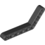 | 4 | Black | Beams |  | Technic Angular Beam 4X6 |  | 88
 | 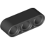 | 2 | Black | Beams |  | Technic 3M Beam |  | 129
 | 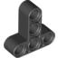 | 4 | Black | Beams |  | T-Beam 3X3 W/Hole Ø4.8 |  | 39
 | 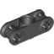 | 8 | Black | Beams, Special |  | Double Cross Block |  | 155
 | 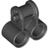 | 4 | Black | Beams, Special |  | Technic Cross Block 2X1 |  | 112
 | 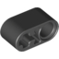 | 4 | Black | Beams, Special |  | Beam 1X2 W/Cross And Hole |  | 44
 | 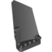 | 1 | Black | Beams, With Bows |  | Left Panel 5X11 |  | 5
 | 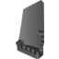 | 1 | Black | Beams, With Bows |  | Right Panel 5X11 |  | 5
 | 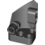 | 1 | Black | Beams, With Bows |  | Right Panel 3X5 |  | 8
 | 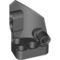 | 1 | Black | Beams, With Bows |  | Left Panel 3X5 |  | 8
 | 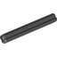 | 4 | Black | Connectors |  | Cross Axle 4M |  | 758
 | 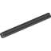 | 4 | Black | Connectors |  | Cross Axle 6M |  | 633
 |  | 2 | Black | Connectors |  | Cross Axle 8M |  | 425
 |  | 2 | Black | Connectors |  | Cross Axle 12M |  | 288
 |  | 2 | Black | Connectors |  | Cross Axle 10M |  | 373
 | 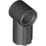 | 4 | Black | Connectors |  | Angle Element, 0 Degrees [1] |  | 284
 | 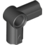 | 2 | Black | Connectors |  | Angle Element, 90 Degrees [6] |  | 116
 | 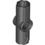 | 4 | Black | Connectors |  | Angle Element, 180 Degrees [2] |  | 180
 | 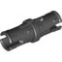 | 60 | Black | Connectors |  | Connector Peg W. Friction |  | 1233
 | 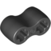 | 4 | Black | Connectors |  | Damper 2M |  | 70
 | 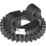 | 2 | Black | Functional Elements |  | Upper Part For Turntable Z28 |  | 5
 | 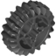 | 2 | Black | Functional Elements, Gear Wheels And Racks |  | Double Conical Wheel Z20 1M |  | 39
 | 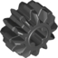 | 2 | Black | Functional Elements, Gear Wheels And Racks |  | Double Conical Wheel Z12 1M |  | 160
 | 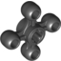 | 4 | Black | Functional Elements, Gear Wheels And Racks |  | Technic Angular Wheel |  | 40
 | 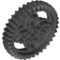 | 2 | Black | Functional Elements, Gear Wheels And Racks |  | Double Conical Wheel Z36 |  | 27
 | 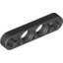 | 2 | Black | Half Beams |  | Lever 1X4, Without Notch |  | 94
 | 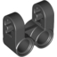 | 4 | Black | Half Beams, Special |  | Technic Cross Block/Fork 2X2 |  | 92
 | 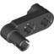 | 2 | Black | Half Beams, Special |  | 2X1X3 Steering Knuckle Arm |  | 53
 |  | 2 | Black | Tires And Rims For/To Snap Ø4,85 W. Cross |  | Tyre Low Wide Ø56 X 28 |  | 2
 | 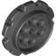 | 4 | Black | Tires And Rims, Special |  | Sprocket, Ø¸40,7 |  | 5
 | 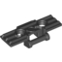 | 54 | Black | Tires And Rims, Special |  | Track Element, 5X1,5 |  | 2
 |  | 4 | Black | Tires And Rims, Special |  | Tyre For Wedge-Belt Wheel |  | 11
 | 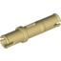 | 6 | Brick Yellow | Connectors |  | 3M Connector Peg |  | 151
 | 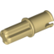 | 8 | Brick Yellow | Connectors |  | Connector Peg/Cross Axle |  | 159
 | 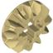 | 2 | Brick Yellow | Functional Elements, Gear Wheels And Racks |  | Conical Wheel Z12 |  | 81
 | 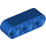 | 4 | Bright Blue | Beams |  | Technic 3M Beam |  | 16
 | 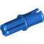 | 20 | Bright Blue | Connectors |  | Conn.Bush W.Fric./Crossale |  | 828
 | 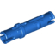 | 30 | Bright Blue | Connectors |  | Connector Peg W. Friction 3M |  | 322
 | 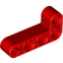 | 6 | Bright Red | Beams |  | Technic Ang. Beam 4X2 90 Deg |  | 47
 | 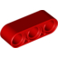 | 4 | Bright Red | Beams |  | Technic 3M Beam |  | 48
 |  | 2 | Bright Red | Beams, Special |  | Hto V Beam 90 Degr. |  | 1
 | 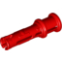 | 22 | Bright Red | Connectors |  | 2M Fric. Snap W/Cross Hole |  | 128
 | 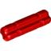 | 10 | Bright Red | Connectors |  | 2M Cross Axle W. Groove |  | 618
 | 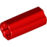 | 6 | Bright Red | Connectors |  | Cross Axle, Extension, 2M |  | 57
 | 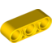 | 4 | Bright Yellow | Beams |  | Technic 3M Beam |  | 47
 |  | 10 | Bright Yellow | Connectors |  | 1/2 Bush |  | 201
 | 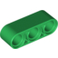 | 4 | Dark Green | Beams |  | Technic 3M Beam |  | 1
 | 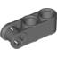 | 8 | Dark Stone Grey | Beams, Special |  | Cross Blok 3M |  | 65
 | 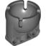 | 1 | Dark Stone Grey | Beams, Special |  | Power Joint |  | 6
 |  | 2 | Dark Stone Grey | Connectors |  | Cross Axle 8M With End Stop |  | 151
 | 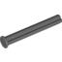 | 2 | Dark Stone Grey | Connectors |  | Cross Axle 4M With End Stop |  | 186
 | 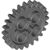 | 4 | Dark Stone Grey | Functional Elements, Gear Wheels And Racks |  | Gear Wheel Z24 |  | 68
 | 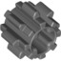 | 4 | Dark Stone Grey | Functional Elements, Gear Wheels And Racks |  | Gear Wheel T=8, M=1 |  | 45
 | 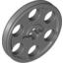 | 4 | Dark Stone Grey | Tyres And Rims, Special |  | Wedge-Belt Wheel Ø24 |  | 10
 | 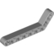 | 4 | Medium Stone Grey | Beams |  | Technic Angular Beam 3X7 |  | 23
 | 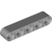 | 4 | Medium Stone Grey | Beams |  | Technic 5M Beam |  | 66
 | 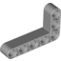 | 2 | Medium Stone Grey | Beams |  | Technic Ang. Beam 3X5 90 Deg. |  | 46
 | 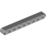 | 6 | Medium Stone Grey | Beams |  | Technic 9M Beam |  | 39
 | 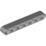 | 4 | Medium Stone Grey | Beams |  | Technic 7M Beam |  | 60
 | 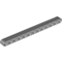 | 6 | Medium Stone Grey | Beams |  | Technic 13M Beam |  | 22
 | 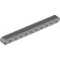 | 4 | Medium Stone Grey | Beams |  | Technic 11M Beam |  | 22
 | 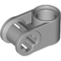 | 8 | Medium Stone Grey | Beams, Special |  | Cross Block 90° |  | 101
 | 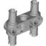 | 6 | Medium Stone Grey | Beams, Special |  | Beam 3 M. W/4 Snaps |  | 122
 | 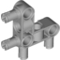 | 4 | Medium Stone Grey | Beams, Special |  | Angular Beam 90Degr. W.4 Snaps |  | 32
 | 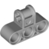 | 6 | Medium Stone Grey | Beams, Special |  | Cross Block 3X2 |  | 40
 | 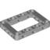 | 3 | Medium Stone Grey | Beams, Special |  | Beam Frame 5X7 Ø 4.85 |  | 28
 | 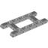 | 1 | Medium Stone Grey | Beams, Special |  | Beam R. Frame 5X11 Ø4.85 |  | 21
 | 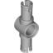 | 4 | Medium Stone Grey | Beams, Special |  | Double Bush 3M Ø4.9 |  | 50
 | 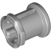 | 10 | Medium Stone Grey | Connectors |  | Bush For Cross Axle |  | 399
 | 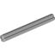 | 6 | Medium Stone Grey | Connectors |  | Cross Axle 5M |  | 358
 | 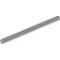 | 5 | Medium Stone Grey | Connectors |  | Cross Axle 7M |  | 248
 | 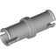 | 10 | Medium Stone Grey | Connectors |  | Connector Peg |  | 442
 | 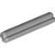 | 14 | Medium Stone Grey | Connectors |  | Cross Axle 3M |  | 598
 | 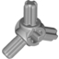 | 2 | Medium Stone Grey | Connectors |  | 3-Branch Cross Axle W/Cross H. |  | 52
 | 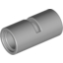 | 4 | Medium Stone Grey | Connectors |  | Tube W/Double Ø4.85 |  | 87
 | 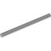 | 2 | Medium Stone Grey | Connectors |  | Cross Axle 9M |  | 74
 | 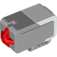 | 2 | Medium Stone Grey | Electric Parts |  | Ms, Ev3, Touch Sensor |  | 3
 | 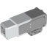 | 1 | Medium Stone Grey | Electric Parts |  | Ms-Ev3, Medium Motor |  | 3
 | 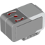 | 1 | Medium Stone Grey | Electric Parts |  | Ms, Ev3, Gyro Sensor |  | 2
 | 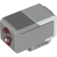 | 1 | Medium Stone Grey | Electric Parts |  | Ms, Ev3, Sensor, Colour |  | 3
 | 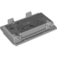 | 1 | Medium Stone Grey | Electric Parts |  | Ms-Ev3 Rechargeable Battery |  | 2
 |  | 2 | Medium Stone Grey | Functional Elements |  | Lower Part For Turntable Z28 |  | 5
 | 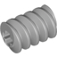 | 2 | Medium Stone Grey | Functional Elements, Gear Wheels And Racks |  | Worm |  | 75
 | 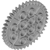 | 2 | Medium Stone Grey | Functional Elements, Gear Wheels And Racks |  | Gear Wheel 40T |  | 39
 | 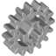 | 4 | Medium Stone Grey | Functional Elements, Gear Wheels And Racks |  | Gear Wheel Z16 |  | 51
 | 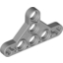 | 4 | Medium Stone Grey | Half Beams |  | Triangle |  | 9
 | 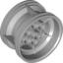 | 2 | Medium Stone Grey | Tyres And Rims For/To Snap Ø4,85 W. Cross |  | Rim Wide 43,2X26 W 6 Hol.Ø 4.8 |  | 16
 | 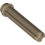 | 2 | Sand Yellow | Connectors |  | Crossaxle 3M With Knob |  | 105
 | 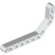 | 4 | White | Beams |  | Double Angular Beam 3X7 45° |  | 12
 | 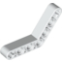 | 6 | White | Beams |  | Technic Angular Beam 4X4 |  | 6
 | 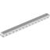 | 6 | White | Beams |  | Technic 15M Beam |  | 15
 | 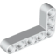 | 4 | White | Beams |  | Technic Ang. Beam 3X5 90 Deg. |  | 7
 | 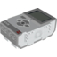 | 1 | White | Electric Parts |  | Ms-Ev3, P-Brick |  | 3
 | 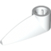 | 4 | White | Modelling Elements |  | Bion. Eye |  | 19

Color summary
Color | Unique | Total
Black | 32 | 202
Brick Yellow | 3 | 16
Bright Blue | 3 | 54
Bright Red | 6 | 50
Bright Yellow | 2 | 14
Dark Green | 1 | 4
Dark Stone Grey | 7 | 25
Medium Stone Grey | 33 | 137
Sand Yellow | 1 | 2
White | 6 | 25
Total | 94 | 529

Category summary
Category | Unique | Total
Beams | 19 | 82
Beams, Special | 13 | 59
Beams, With Bows | 4 | 4
Connectors | 29 | 259
Electric Parts | 6 | 7
Functional Elements | 2 | 4
Functional Elements, Gear Wheels And Racks | 10 | 28
Half Beams | 2 | 6
Half Beams, Special | 2 | 6
Modelling Elements | 1 | 4
Tires And Rims For/To Snap Ø4,85 W. Cross | 2 | 4
Tires And Rims, Special | 4 | 66
Total | 94 | 529

