Robo-Science Accident Challenge: Instruction Guide

This challenge was originally developed by Georgia Tech University, for the SLIDER program. The materials from GA Tech have been trimmed down to shorten the length of the lesson to span about 3-5 class periods, depending on which version of the challenge is chosen.

There are two versions of the challenge, and both are included in the Accident Challenge PPT. The white slides apply to all versions, then the blue slides are for a full-length challenge, and orange slides outline an abridged challenge. The full-length challenge tests 3 speeds and 3 masses, for a total of 9 combinations. The abridged challenge tests only 2 speeds and 2 masses, for a total of 4 combinations.

The Truck Building Instructions (LEGO Digital Designer .lxf files) have two versions, one using only the parts from one 45544 kit and the other using 4 of the 45544 wheels/tires (there are only 2 per kit - extras may be purchased or kits combined).

The lesson also contains an engineering extension exercise (Additional Assessment – Extended) to explore Friction by designing a braking mechanism for the truck.

The components of this lesson were created for a science class where students may or may not have experience building and programming EV3 robots. Therefore, the Primary Instructional Material including building instructions (.ixf files) and the required program (.EV3 file). If this lesson is being taught as a science extension to a STEM Robotics class, students may be challenged to design the car and truck and also write their own program for measuring velocity.

Setup

Below are images of the Accident Challenge setup:

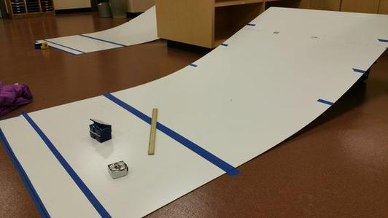
Layout of Ramp – Note “Start” line at bottom of slope and finish line 45cm later. Blue tape at bottom edge is to hold ramp in place. Three start point are marked up each slide of slope (one ramp used for two teams)
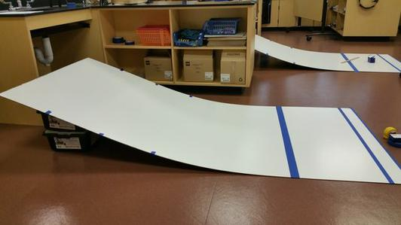
Side View of setup – EV3 kits are used to set height of ramp

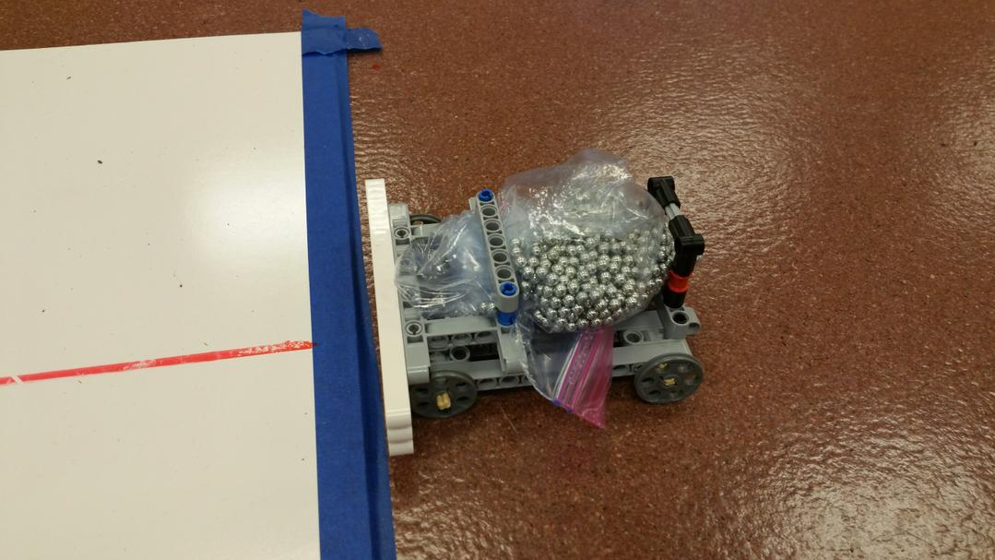
Car model at bottom of ramp

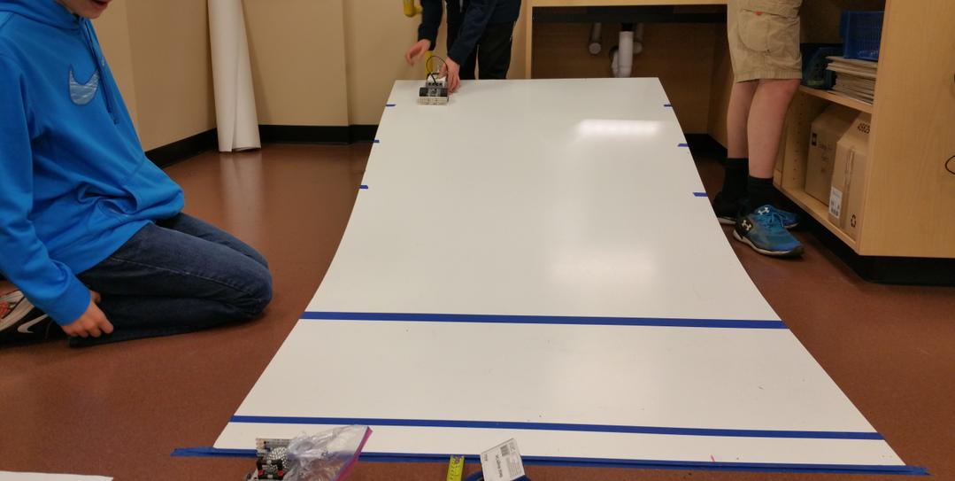
Setting up for highest velocity case

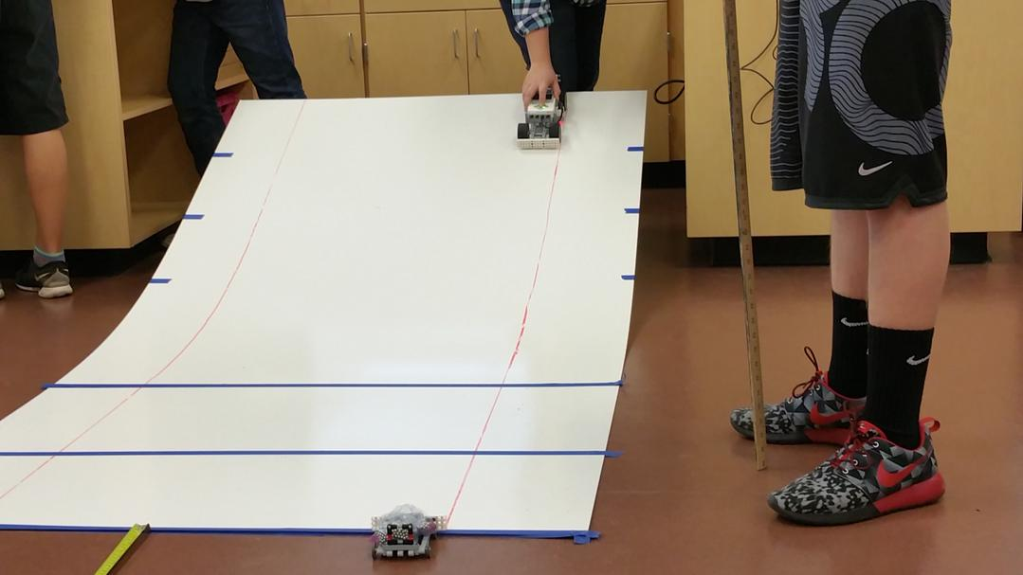
Setting up for highest velocity case

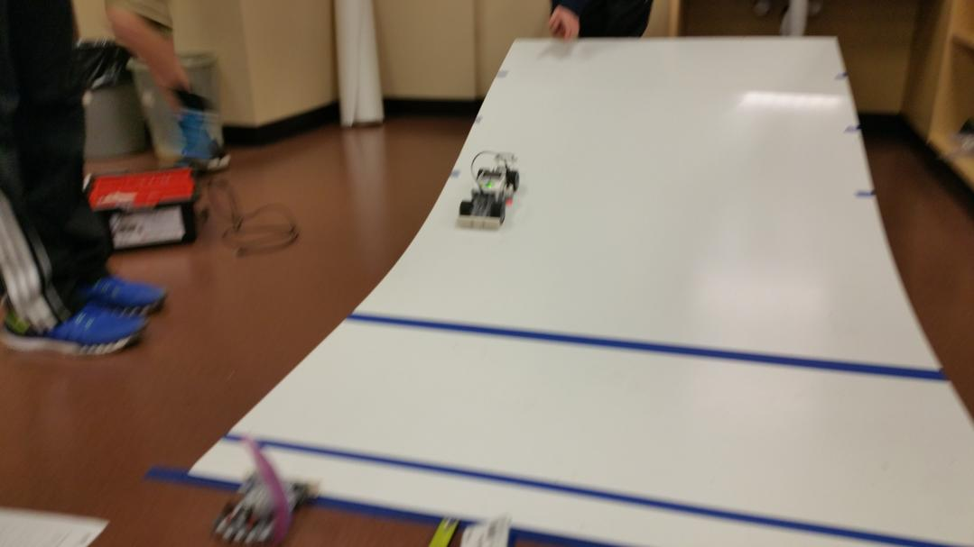
Pending impact

PPT Slideshow Guide:

Slide 2: Introductory Videos:
- Intro to challenge: introduces the challenge
- Collisions 1-3: students should make observations on the front side of “Collision Questions” handout
  - Strike Vehicle hits the Target Vehicle
  - If you do not use the handout:
    - Prompt the students to observe movement of both vehicles before, during, and after the collisions, then discuss.
- Impact Info: students record observations on back side of “Collision Questions” handout
  - Strike Vehicle hits the Target Vehicle
  - If you do not use the handout:
    - Prompt students to observe movement of both vehicles before, during, and after the collisions, then discuss.
    - Discussion points:
      - What did you see/hear during the front impact collision?
      - What did you see/hear during the side impact collision?
      - What are some constraints faced by engineers when modeling collisions in a lab?
- Optional videos: These videos show more car accidents involving vehicles of different sizes.
  - After viewing these videos, ask students how vehicle size affects damage in an accident.
  - Students can relate this information to large trucks hitting cars, as in the challenge.

Slide 3: Traffic Engineer
- Definition of Engineering: Using science and technology to design, build, or develop a solution to a problem

Slide 4: Newspaper article
- Read article to students as an initial introduction to the problem they will be working to solve.
  - Points to emphasize:
    - Accidents have increased drastically over the past year
    - Trucks are hitting cars
- At this point, students should be given the “Organize the Challenge” handout. They can begin completing the “Things we know” section.

Slide 5: The Challenge – Why?
- This information is similar to the information in the article (key points)

Slide 6:
- At this time, students are NOT ready to propose solutions, since they do not have enough information.
  - Students can jot down their ideas in the “Parking Lot” section of their “Organize the Challenge” handout, to revisit later
- Students need to use the scientific process (observations, question, hypothesis, experiment, data analysis, conclusion) to develop their solution proposal.
- Students should complete the “What we want to know” section of their organizer handout

Slide 7:
- Use Lego Digital Designer “Accident Challenge Truck” and “Accident Challenge Car” files to build models
  - Open .lxf file and use View>>> Building Guide mode to get animated step-by-step building instructions
  - Note: there are two Truck models, one using only the parts from a single 45544 kit (“_1Kit”) and another that uses 4 of the 45544 wheels/tires (“_4Tire”). There are only 2 tires per kit - extras may be purchased or kits combined. The 4 Tire version is quieter.
  - Similarly, the .EV3 Project File contains both “1 Kit” and “4 Tire” programs which are identical except for the color sensor light thresholds (due to different ground clearance of the two robot designs). These thresholds may need to be adjusted depending on the particular lab set up.
- It is suggested that student pairs team up with another pair for this experiment
  - One pair will build the truck, while the other will build the car.
  - Students will complete the project as a pair of two, they will just simulate the crashes with another pair to save space and time.
- Notes about the car:
  - The car has been designed to hold a ziploc sandwich bag on top of it.
  - The bag will be filled with bb’s (or other small heavy objects) to make its total mass 250g
    - Without this extra mass, the car will spin out when hit by the truck.
  - Students should place the car and bag on the scale together, then gradually add bb’s until 250 g is reached.
  - The bag can be secured by the beams connected by blue pegs in the car’s “trunk.”
  - Students should try to keep the bag centered on the car throughout the experiment to distribute weight evenly.
  - Students should also keep an eye on the bag’s position and make sure it does not get wedged between the car and a wheel.
Slide 8:
- Students should record information from maps and videos in the “Facts/Observations” section of the organizer handout
- They may also be able to add information to the “Constraints/Limitations” section
- Map 1: City of McFarland
- Wetlands are protected areas, cannot build in these areas
- Three roads: Main St., Park St, Old Stagecoach Rd.
  - Old Stagecoach is the only alternate route
  - It is narrow, windy, long (slow speed limit)
- Town bordered by two highways
- Map 2: Intersection Close-Up
- Left turn from Park to Main must yield
- Through traffic does not stop
- On-ramp feeds directly onto Park St.

Slide 9:
- Map 3: Last year’s accident data
- 7 total accidents
  - Only one had major injuries
  - Map 4: This year’s accident data
- 18 total accidents
  - 13 had major damage
  - Ask: How do the trends seen in the maps change from last year to this year?
- More total accidents
- More cars pushed farther
  - Greater distance pushed means more damage in accident

Slide 10
- Data discussion points:
- Number of total accidents nearly tripled
- Last year, majority of accidents were minor damage to vehicle, minor injuries
- This year, majority of accidents were severe damage to vehicle, severe injuries
  - Two fatalities this year
- Ask: Based on what you know, what may have caused these changes?

Slide 11:
- Additional information to be recorded in “Facts/Observations” and “Constraints/Limitations” sections
- Key points from Mayor:
- Town is bordered by a river and farmland
- Car factory has been an economic benefit to town
  - Distribution center opened South of town last year
  - Increased truck traffic as trucks leave loaded with parts
  - Car warehouse has on-ramp directly to highway
- Trucks are hitting cars from behind
- No light at intersection, left turn yields (stops) to wait but most trucks turn left
- Key points from Police Chief:
- Amount and severity of accidents have increased in past year
  - This year there were 2 fatalities
- Collisions occurring when car is waiting to turn left and is hit from behind by a truck
- This year, majority of car accidents are severe and further away from site of collision

Slide 12:
- Students should share responses to the questions above based on information they recorded in their organizer

Slide 13:
- Existing scientific knowledge needed (examples):
- Speed, velocity, and acceleration
- Momentum
- Newton’s Laws of Physics
  - 1st Law: Law of inertia
  - 2nd Law: F = ma
  - 3rd Law: Action-reaction force pairs
- Kinetic and potential energy
- Law of Conservation of Energy
- Work
- Force
- Friction
- Possible solutions:
- Students will have many ideas – using limitations of BUDGET (very low) and TIME (very little), help them narrow down suggestions.
- Guide conversation to the ideas of limiting WEIGHT (mass) and/or SPEED.
  - Do not allow students to propose solution YET – just narrow down where they are going to focus efforts.
  - Additional research is needed to determine values for speed and/or mass limits, they cannot be obscure.

Slide 14:
- Following this slide, choose one version of the activity to complete:
- Expanded Version:
  - If you want to test 3 speeds and 3 masses, use slides 15-23 (blue background)
- Abridged Version:
  - If you want to test 2 speeds and 2 masses, use slides 24-32 (orange background)

Slides 15-23: Expanded Version:
Slide 15:
- In this setup, all ramps will be set up the same. Two groups can share each ramp (one group on either side).
- Students should measure the height of their ramp at the highest point. They should check their ramps before each trial to ensure that this height remains consistent throughout the experiment, because if the height changes, that means that the ramp angle has also changed. If the height changes, they need to adjust the board to return to the starting height.

Slide 16:
Students should share their responses to the questions. Discussion points are below.
- How can we model different truck speeds?
  - Because of gravity and acceleration, the truck will gain speed as it comes down the ramp. The longer it is on the ramp, the more time it will be able to accelerate, and thus, the faster its speed.
  - Because of potential energy, the truck will have more energy if it starts from a higher position on the ramp.
    - The law of conservation of energy states that energy cannot be created or destroyed, only transformed.
    - Potential energy is converted to kinetic energy, and thus, a truck with constant mass that has a greater height (more potential energy) at the top of the ramp will have a greater speed (more kinetic energy) at the bottom of the ramp
- How can we model different truck masses?
  - We can add mass to the bed of the truck to weigh it down
  - You do NOT need to change the design of the truck, it is designed to hold extra load in its bed
- How can we test both variables (speed and mass) and still have a valid experiment?
  - Students will actually be conducting two experiments at once
  - The experiment is valid because they will test all possible combinations of speed and mass, which is like doing two experiments
    - Test same mass at high, mid, low speed
    - Test same speed with high, mid, low mass
- What is the dependent/responding variable?
  - Distance that the car travels after being hit by the truck
    - Remember, greater distance means greater damage
- What variables should be controlled?
  - All variables besides truck mass, release height, and distance car travels after impact should be controlled. This includes, but is not limited to:
    - Ramp angle
    - Truck release technique
    - Mass of car
    - Starting point of measurement for car distance

Slide 17:
- Emphasize the importance of using data to come up with a solution to the problem
- Students will need to test 9 combinations (3 speeds x 3 masses = 9 total combinations)
- Momentum is a product of mass and velocity. P = mv
  - When the truck’s mass increases, the truck’s momentum should also increase
  - When the truck’s speed increases, the truck’s momentum should also increase
    - Students will determine whether mass and speed affect distance the car is pushed, or if mass OR speed has a greater effect.
    - They will use this information to propose a mass limit, speed limit, or both.

Slide 18:
- Students should mark from the front of the truck’s bumper to indicate one truck length. Then, they can just line up the bumper with the line they drew for each trial at that release height.
- Use mass kits, or other small objects with fixed mass, to load the truck. The car’s mass remains constant.

Slide 19:
- Students will need to run program “Accident Challenge” for this experiment
  - This program will calculate and display the truck’s speed on the brick
- The car will say “start” and “stop” to acknowledge when it crosses the tape lines
  - Students must listen carefully to make sure both are said at the appropriate times
  - If they are not said at appropriate times, then that trial is invalid and should be repeated
- The speed should remain fairly constant for any trials conducted from the same height, regardless of truck mass
- Use “Simulation Data_Expanded” data table handout to collect data for truck speed and car distance
  - Students will do three trials each for all nine mass/speed combinations
  - Car distance should be measured in cm

Slide 20:
- To calculate scale factor, use the following ratio:
- 40 mph / (highest simulation speed) m/s = X mph / 1 m/s
  - Solve for X
- Students will multiply their simulation speeds (in m/s) by X to convert them to a real-life speed in mph

Slide 21:
- Students can use graphing programs (Google Sheets, Microsoft Excel, etc.) or make graphs by hand
- For bar graph:
  - Calculate and graph the average car distance for each truck condition (speed/mass combo)
  - Manipulated variable (x-axis) is truck conditions (mass/speed combo) – there will be nine conditions
  - Responding variable (y-axis) is car distance
- After bar graph is made, students identify the tallest bar, representing the distance of the car that was pushed the farthest
  - Note the speed and mass combo that lead to this tallest bar
    - (teacher hint: the tallest bar should be one of the high speed conditions, but may not be the heaviest load)
  - The speed (release height) that resulted in tallest bar is “target speed”
  - The mass that resulted in the tallest bar is “target mass”
- Target Speed:
  - Create a scatterplot (x-y graph) that compares mass vs. distance for that speed only (all three masses when truck released at chosen height)
  - There will be THREE points on the graph
    - Mass is manipulated variable (x-axis)
    - Car distance is dependent variable (y-axis)
- Target Mass:
  - Create a scatterplot (x-y graph) that compares speed vs. distance for that mass only (all three speeds/release height for the truck with chosen mass)
  - There will be THREE points on the graph
    - Mass is manipulated variable (x-axis)
    - Car distance is dependent variable (y-axis)
- (Teacher hint): The scatterplots should show a trend (direct relationship) for speed vs. distance, but NO trend should be seen for mass vs. distance
  - A.K.A. Students should see that increasing truck speed increases the car distance, but truck mass has no effect on car distance

Slide 22:
- Students should determine bar height levels that indicate severity of damage
  - There should be few fatal accidents (1-2 maximum)
  - The remaining accidents should be classified as major or minor damage
- The tallest bar (should be one of the high speed trucks, mass may vary) represents the conditions that will most likely lead to fatal accidents
- Truck speed has a greater impact on car distance than truck mass
  - This is because of the Law of Conservation of Energy and Kinetic Energy
    - Trucks with higher speed (higher release height) have more energy
    - This energy is transferred to the car
    - Speed has a greater impact because KE = ½ m v², so increases to velocity (speed) will lead to a greater increase in energy than any changes made to mass, since velocity is squared when calculating kinetic energy

Slide 23:
- (Teacher hint): Students should propose a SPEED LIMIT, but not a mass limit
  - Data must be used to support proposal (there must be scientific reasoning for solution proposed)
  - Students should use the converted speed (in mph) that they calculated previously to propose their speed limits
  - The proposed solution should maximize efficiency while increasing safety
    - For example, students should propose a speed limit that is the highest speed that only leads to minor accidents.
    - Students should not make any proposals that they cannot defend with their data.

Slides 24-32: Abridged Version:
Slide 24:
- In this setup, there will be two ramp heights: low and high. Groups will use both ramps to manipulate the speed of their truck.
- Students should measure the height of each ramp at the highest point. They should check the ramps before each trial to ensure that this height remains consistent throughout the experiment, because if the height changes, that means that the ramp angle has also changed. If the height changes, they need to adjust the board to return to the starting height.

Slide 25:
Students should share their responses to the questions. Discussion points are below.
- How can we model different truck speeds?
  - Because of gravity and acceleration, the truck will gain speed as it comes down the ramp. The longer it is on the ramp, the more time it will be able to accelerate, and thus, the faster its speed.
  - Because of potential energy, the truck will have more energy if it starts from a higher position on the ramp.
    - The law of conservation of energy states that energy cannot be created or destroyed, only transformed.
    - Potential energy is converted to kinetic energy, and thus, a truck with constant mass that has a greater height (more potential energy) at the top of the ramp will have a greater speed (more kinetic energy) at the bottom of the ramp
- How can we model different truck masses?
  - We can add mass to the bed of the truck to weigh it down
  - You do NOT need to change the design of the truck, it is designed to hold extra load in its bed
- How can we test both variables (speed and mass) and still have a valid experiment?
  - Students will actually be conducting two experiments at once
  - The experiment is valid because they will test all possible combinations of speed and mass, which is like doing two experiments
    - Test same mass at high and low speed
    - Test same speed with high and low mass (full and empty truck)
- What is the dependent/responding variable?
  - Distance that the car travels after being hit by the truck
    - Remember, greater distance means greater damage
- What variables should be controlled?
  - All variables besides truck mass, release height, and distance car travels after impact should be controlled. This includes, but is not limited to:
    - Ramp angle
    - Truck release technique
    - Mass of car
    - Starting point of measurement for car distance

Slide 26:
- Emphasize the importance of using data to come up with a solution to the problem
- Students will need to test 4 combinations (2 speeds x 2 masses = 4 total combinations)
- Momentum is a product of mass and velocity. P = mv
  - When the truck’s mass increases, the truck’s momentum should also increase
  - When the truck’s speed increases, the truck’s momentum should also increase
    - Students will determine whether mass and speed affect distance the car is pushed, or if mass OR speed has a greater effect.
    - They will use this information to propose a mass limit, speed limit, or both.

Slide 27:
- Students should mark from the front of the truck’s bumper to indicate one truck length. Then, they can just line up the bumper with the line they drew for each trial at that release height.
- Use mass kits, or other small objects with fixed mass, to load the truck. The car’s mass remains constant.

Slide 28:
- Students will need to run program “Accident Challenge” for this experiment
  - This program will calculate and display the truck’s speed on the brick
- The car will say “start” and “stop” to acknowledge when it crosses the tape lines
  - Students must listen carefully to make sure both are said at the appropriate times
  - If they are not said at appropriate times, then that trial is invalid and should be repeated
- The speed should remain fairly constant for any trials conducted from the same height, regardless of truck mass
- Use “Simulation Data_Abridged” data table handout to collect data for truck speed and car distance
  - Students will do three trials each for all four mass/speed combinations
  - Car distance should be measured in cm

Slide 29:
- To calculate scale factor, use the following ratio:
- 40 mph / (highest simulation speed) m/s = X mph / 1 m/s
  - Solve for X
- Students will multiply their simulation speeds (in m/s) by X to convert them to a real-life speed in mph

Slide 30:
- Students can use graphing programs (Google Sheets, Microsoft Excel, etc.) or make graphs by hand
- For bar graph:
  - Calculate and graph the average car distance for each truck condition (speed/mass combo)
  - Manipulated variable (x-axis) is truck conditions (mass/speed combo) – there will be four conditions
  - Responding variable (y-axis) is car distance
- After bar graph is made, students identify the tallest bar, representing the distance of the car that was pushed the farthest
  - Note the speed and mass combo that lead to this tallest bar
    - (teacher hint: the tallest bar should be one of the high speed conditions, but may not be the full truck)
  - The speed (low or high) that resulted in tallest bar is “target speed”
  - The mass (empty or full) that resulted in the tallest bar is “target mass”
- Target Speed:
  - Compare mass vs. distance for that speed only
    - How does increasing the mass affect the distance the car travels at this speed?
- Target Mass:
  - Compare speed vs. distance for that mass only
    - How does increasing the speed affect the distance the car travels at this mass?
    - (Teacher hint): Students should observe a trend (direct relationship) for speed vs. distance, but NO trend should be seen for mass vs. distance
  - A.K.A. Students should see that increasing truck speed increases the car distance, but truck mass has no effect on car distance

Slide 31:
- Students should determine bar height levels that indicate severity of damage
  - There should be few fatal accidents (maybe 1)
  - The remaining accidents should be classified as major or minor damage
- The tallest bar (should be one of the high speed trucks, mass may vary) represents the conditions that will most likely lead to fatal accidents
- Truck speed has a greater impact on car distance than truck mass
  - This is because of the Law of Conservation of Energy and Kinetic Energy
    - Trucks with higher speed (higher release height) have more energy
    - This energy is transferred to the car
    - Speed has a greater impact because KE = ½ m v², so increases to velocity (speed) will lead to a greater increase in energy than any changes made to mass, since velocity is squared when calculating kinetic energy

Slide 32:
- (Teacher hint): Students should propose a SPEED LIMIT, but not a mass limit
  - Data must be used to support proposal (there must be scientific reasoning for solution proposed)
  - Students should use the converted speed (in mph) that they calculated previously to propose their speed limits
  - The proposed solution should maximize efficiency while increasing safety
    - For example, students should propose a speed limit that is the highest speed that only leads to minor accidents.
    - Students should not make any proposals that they cannot defend with their data.

