**Grade 6**

**Session 2**

**Introduction to Hardware-Lego 9797**

**Learning objectives**

Towards the end of this session you will be able to:

* Identify the elements in the kit and describe the functions of them
* Recognize the real time application of them

**Materials needed**

1. Lego 9797 kit

2. Paper, pen, color pencils

**STRUCTURAL ELEMENTS**

**BEAMS AND PLATES**

Find the below pieces in your kits - take them out and then close your kits.

* **Can you work out which pieces are plates, beams and studded beams?**

1.

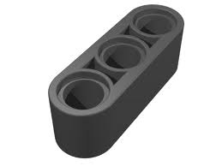

2. 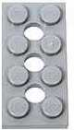

3. C:\Documents and Settings\user\My Documents\My Pictures\studded beam 1.JPG

4. C:\Documents and Settings\user\My Documents\My Pictures\b.JPG

5.

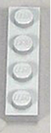

6.

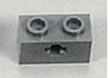

What color are all these pieces in your kit?

Do all the plates have holes in them? Yes or No?

Do all the beams have holes in them?

What do we call the little bumps on top of the beams and plates?

***This piece is called 3 module beam, one hole is called a “Module”***

***This piece C:\Documents and Settings\user\My Documents\My Pictures\studded beam 1.JPG is called 1*6 (stud) beam***

***This piece C:\Documents and Settings\user\My Documents\My Pictures\untitled.bmp is called 2*4(stud) plate with holes***

* **Can you work out what we call the following pieces?**

*Without names trying to describe the pieces would be laborious (sometimes humorous) task. Imagine that Ram asks you to grab the long piece with holes that looks like a stick. Using a term like beam instead is much easier, isn’t it? So remember to use appropriate names for the pieces!*



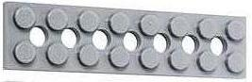

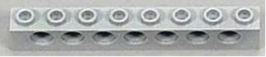 

**C:\Documents and Settings\user\My Documents\My Pictures\digun .sbi.JPG**

**C:\Documents and Settings\user\My Documents\My Pictures\b.JPG**

Look at all the pieces you have taken out of the kit

How many studs are there in the longest beam?

The shortest plate?

The piece in your kit with the most studs?

* **Find these pieces in your kit-take them out and close your kit**

In what way are the set of beams towards the right side differ from that on the left?

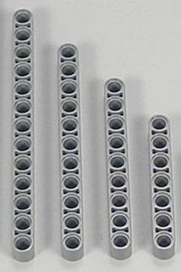 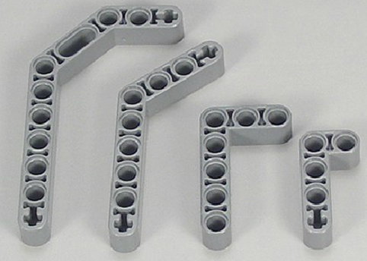

  

|  |  |
| --- | --- |
|  | they also have cross holes |

 

***A beam that is not straight is called an Angular beam***

***That is because it has been bent at an angle***

**AXLES**

An axle is a rod used for 2 purposes, they are:

1. Joining pieces 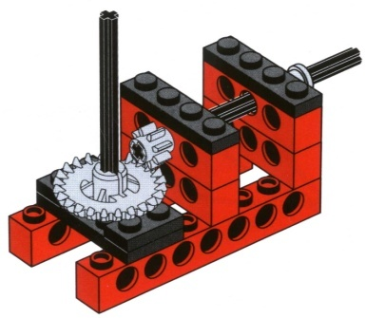 2.Mounting wheels 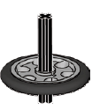

**Measuring Axle**

We count the number of holes to get the length of an axle.

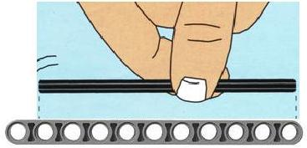

Above is an example of a?

(a) 4 Module axle (b) 6 module axle (c) 8 module axle (d) 10 module axle (e) 12 module axle

**Look at all the axles in your sorting tray.**

What is the length of:

(a) The longest axle - (b) The shortest axle-

How many of the following lengths do you have in your kit, and what color are they?

2 module axle_____________________ 6 module axle_____________________

3 module axle_____________________ 8 module axle_____________________

4module axle_____________________ 10 module axle_____________________

5 module axle_____________________ 12 module axle_____________________

What is the difference between the grey axles and the black axles?

**Connector pegs**

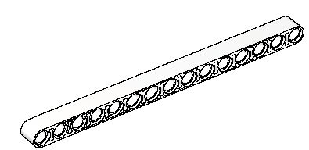Find these pieces in your set - take them out and then close your kits.

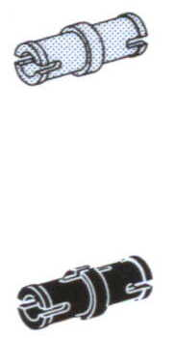



***The black and the blue  are called connector pegs***

Look carefully at the connector pegs:

1. Are they of same size?

2. Are they the same color?

3. Are they the same shape?

**Build**

**Connect the beams together like shown below:**





Similarly, connect beams with 

How many modules could you connect with? What can you call the black peg?

How many modules could you connect with? What can you call the blue peg?

**Build**

* Build a *Rectangle* using beams and pegs

How many beams did you use?

How many pegs did you use?

**N**

**Y**

Turn and twist your Rectangle. Did it turn?

* Build a *Square* using beams and pegs

How many beams did you use?

How many pegs did you use?

**N**

**Y**

Turn and twist your Square. Did it turn?

* Build a *Triangle* using beams and pegs

How many beams did you use?

How many pegs did you use?

**N**

**Y**

Are all the sides of your Triangle equal?

Turn and twist your Triangle. Did it turn?

**N**

**Y**

Which one do you think is the strongest structure Square Triangle Rectangle.Why?

Find these pieces in your kit-take them out and then close your kit

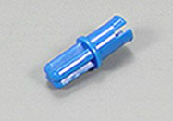 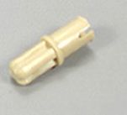 2 *  2 *C:\Documents and Settings\user\My Documents\My Pictures\mod 5.JPG

Build the following using these pieces

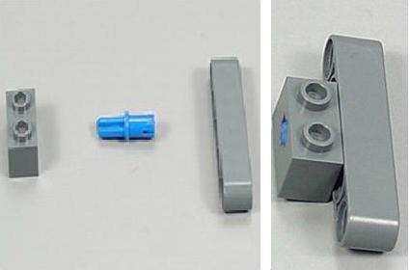 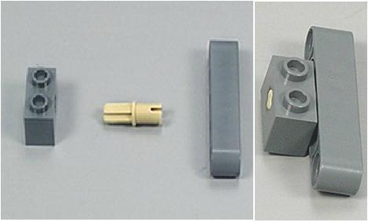

Are 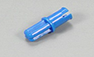 and 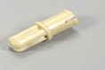 of same size?

**NnNnN**

**Y**

Are  and  of same size?

**NNNN**

**Y**

Which one of the two was easy to build, model with the blue peg? model with the yellow peg?

Do you know why?

Ram wants to build a scissor and a tower using your kit. Can you tell where will he use the blue peg and the yellow peg? Why? Also can you list down the rest of the parts he would need to build the two?

**Bushings**

Find these pieces in your kit-take them out and close your kit:

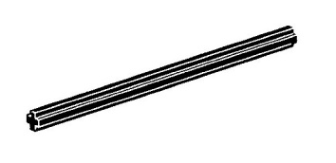2 * 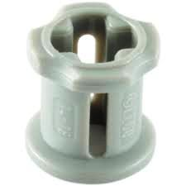 C:\Documents and Settings\user\My Documents\My Pictures\b.JPG 6 module

**Build**

Slide the axle through the beam and push 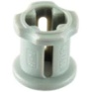 this tightly onto both sides of the beams like below:

|  |  |  |  |  |  |  |  |  |  |  |  |  |  |  |  |
| --- | --- | --- | --- | --- | --- | --- | --- | --- | --- | --- | --- | --- | --- | --- | --- |
|  |  |  |  |  |  |  |  |  |  |  |  |  |  |  |  |
|  |  |  |  |  |  |  |  |  |  |  |  |  |  |  |  |
|  |  |  |  |  |  |  |  |  |  |  |  |  |  |  |  |
|  |  |  |  |  |  |  |  |  |  |  |  |  |  |  |  |
|  |  |  |  |  |  |  |  |  |  |  |  |  |  |  |  |
|  |  |  |  |  |  |  |  |  |  | C:\Documents and Settings\user\My Documents\My Pictures\b.JPG |  |  |  |  |  |
|  |  |  |  |  |  |  |  |  |  |  |  |  |  |  |  |
|  |  |  |  |  |  |  |  |  |  |  |  |  |  |  |  |
|  |  |  |  |  |  |  |  |  |  |  |  |  |  |  |  |
|  |  |  |  |  |  |  |  |  |  |  |  |  |  |  |  |
|  |  |  |  |  |  |  |  |  |  |  |  |  |  |  |  |
|  |  |  |  |  |  |  |  |  |  |  |  |  |  |  |  |
|  |  |  |  |  |  |  |  |  |  |  |  |  |  |  |  |
|  |  |  |  |  |  |  |  |  |  |  |  |  |  |  |  |
|  |  |  |  |  |  |  |  |  |  |  |  |  |  |  |  |

Turn;twist your model to find out if the axle falls out

**N**

**Y**

What happens if only one  is used instead of two?

**Now try connecting two such beams with the same method**

Do you think this is a weak or a strong method to connect beams

**Strong**

**Weak**

***The little grey* * are called Bushings. They are like the bolts that screw onto the ends of nuts*** .

What was the job (function) of the little grey pieces?

Stop the beams from turning Stop the axle from turning

To fasten the beams together Stop the axles from falling out

**Gears**

Find these pieces in your kit-Take them out and close your kit:

C:\Documents and Settings\user\My Documents\My Pictures\8 t.GIF 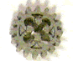 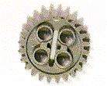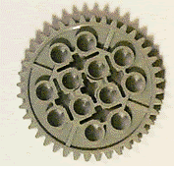

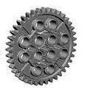

***The part where the arrows are pointing is called the “Tooth” of a gear*. *We identify a gear with the number of tooth on it.***

***C:\Documents and Settings\user\My Documents\My Pictures\8 t.GIF* This is an 8 tooth gear.**

Can you work out the names of the gears below?

*  *

**ELECTRONIC COMPONENTS**

**Find the below device in your kit-take it out and close your kit**

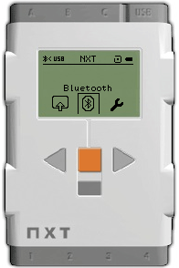

***The device above is called “Nxt Brick”.It controls the functions of your Robot.The slots on the top and bottom of the brick are called “Ports”***

What ports do you see on the top of the brick?

B D A C USB

What ports do you see at the bottom of the brick?

2 4 1 5 3

*Ports on the top are called output ports while those at the bottom are called input ports.*

Can you identify the input ports on the brick? Name them.

Can you identify the output ports on the brick? Name them.

How many input and output ports are there on the brick?

What happens if input is not given to the Robot?

Can you compare the Nxt brick with any of our organs?

Which one?

Ram wants to play cricket. He programs his Robot to be his bowler; can you identify the input in this scenario? Also identify the output?

**Motors**

Find the below device in your kit-take it out and close your kit

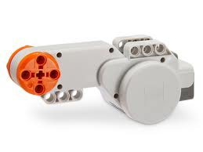

***The above device is called “Motor”. Motors enable your Robot to move from one place to another. They are connected to the ports on the top of the Brick.***

Can you connect 4 motors to the brick at a time? If yes how? If no why?

Is motor an input device or output device?

Can you compare the motor with any of our body parts? Which one?

**Sensors**

Find the below devices in your kit-take them out and close your kit

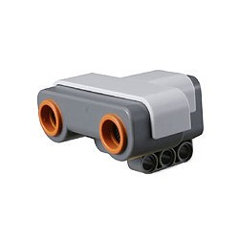 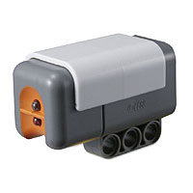 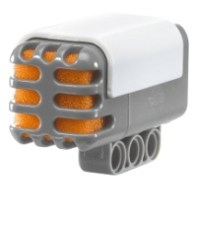 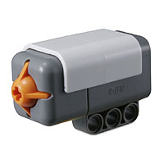

***These devices are called “sensors”. They are like human “senses”. Sensors are connected to the ports at the bottom of the brick.***

What is a function of a sensor?

Why should sensors be used in Robots?

Is sensor an input device or an output device?

Can you identify some of your day to day activities and list them as input and output.

* ***Ultrasonic sensor****-Detects obstacle-Measures distance between the Robot and the obstacle. It is connected to port 4*



Can you compare ultrasonic sensor any human organ? Which one?

What happens if Ultrasonic sensor is connected to port A?

* ***Light sensor****-Detects light-Connected to port 3*



Can you compare light sensor with any human organ? Which one?

* ***Sound sensor****-Detects sound-Connected to port 2*

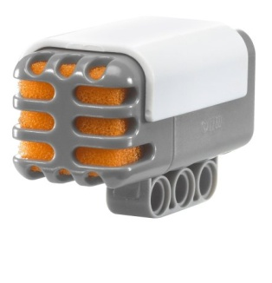

Can you compare sound sensor with any human organ? Which one?

Can sound sensor help the Robot speak? If yes how? If no why?

* ***Touch sensor****-Detects whether it is currently pressed-has been bumped or released-It is connected to port 1*



Can you compare sound touch with any human organ? Which one?

What happens if Ultrasonic sensor is replaced with Touch sensor?

**Cables**

Find these parts in your kit-take them and close your kit

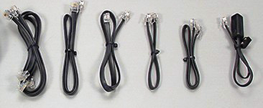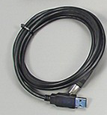

***These parts are called “Cables”. Cables connect the input and output devices to the brick***

**USB cable**



***This part is called the “USB” cable, which is used to connect your Robot and computer****.*

Can you compare the cables with any human organ? Which one?

**Tyres and Wheels**

Find these pieces in your kit-take them out and close your kit

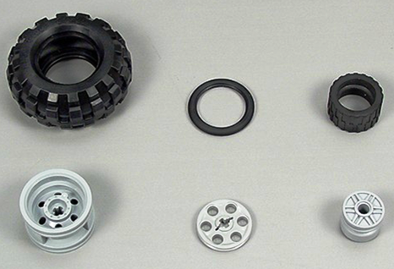 

Wider tires will reduce the stress per unit area!

*The above parts which are black in color are called “Tires”. The parts in grey color are called “Wheels”. Tires and Wheels are connected to motors of the Robot.*

If Ram needs to choose the size of the tire for his Robot which has to carry a heavy load, which tire would he choose small or big?

What happens if the smaller tire is replaced with the bigger tire or vice versa?

Using the above hardware, design a Robot for a specific task, List down the structural and electronic components you would use along with their functions.

