Using Sensors to Start and Stop

Build a two motor vehicle (REM Bot or Riley Rover) or a vehicle of your choice. Attach a touch sensor where you can easily reach it and attach and attach an ultrasonic sensor on the font facing forward.
(The program below was written using the iPad version of the software, you may have to adapt it for a desktop/laptop version of the software.) Be sure to check your wires and ports so that your commands match your physical robot.

- Bring out a “Wait For” block from the orange Flow pallet.
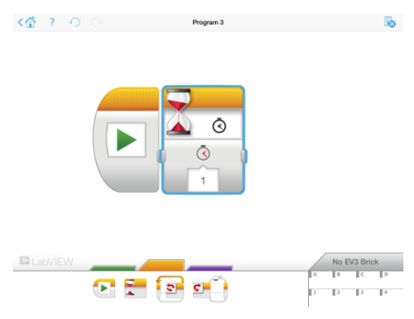
- Modify the block so that it is waiting for the touch sensor to be pushed in. Touch>Compare State>Pushed In
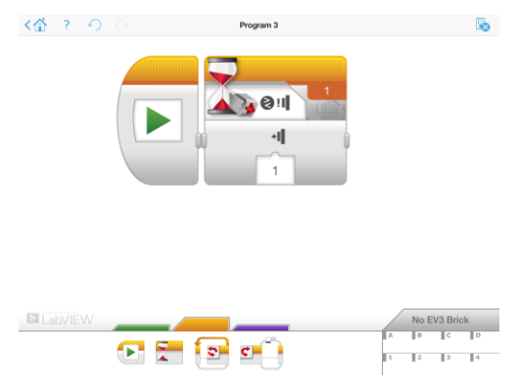
- Add a “Move Steering” block, set to unlimited duration at a medium speed.
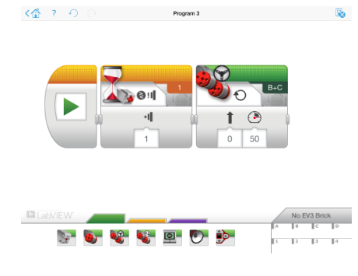
- Use another “Wait For” block and choose the Ultrasonic>Compare Distance>Less Than mode. This will trigger the condition when the ultrasonic sensor senses an object less than ten centimeters away.
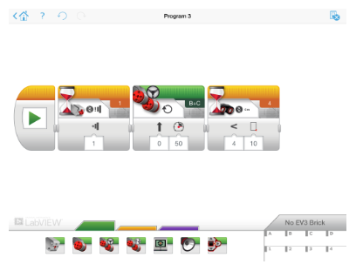

- Finally add another “Move Steering” block and modify it so it makes the motors stop at this point.
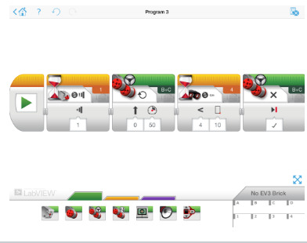

If your ports are correct and your program is written properly, you should be able to start your robot by pushing the touch sensor and then stop it by waving your hand or other object in front of it.

